Task 5: Multi-Tenant EKS Setup (Namespaces + RBAC + NetworkPolicies + Prometheus + Grafana)
Goal: Implement isolation between internal teams.
Implement a fully isolated multi-tenant architecture within a single AWS EKS cluster. Each tenant (Team-A, Team-B) must have:
· Separate namespaces
· Separate RBAC access
· Network isolation (deny cross-namespace communication)
· Prometheus scraping only allowed for that team
· Grafana dashboards visible only to that team

- Create cluster
eksctl create cluster -f cluster.yaml

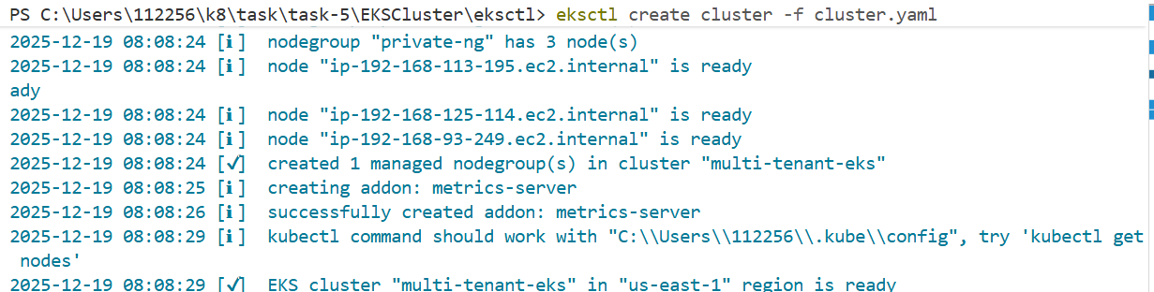

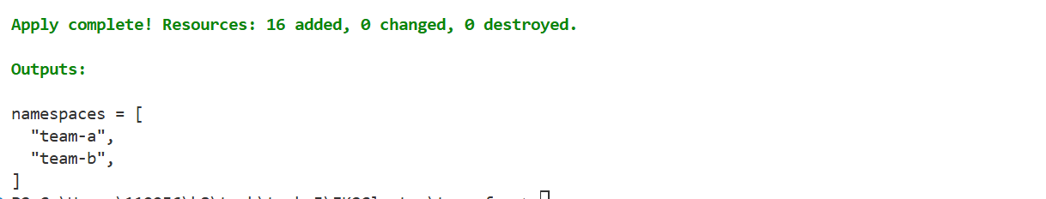

kubectl port-forward -n team-a deploy/grafana 3000:3000
http://localhost:3000

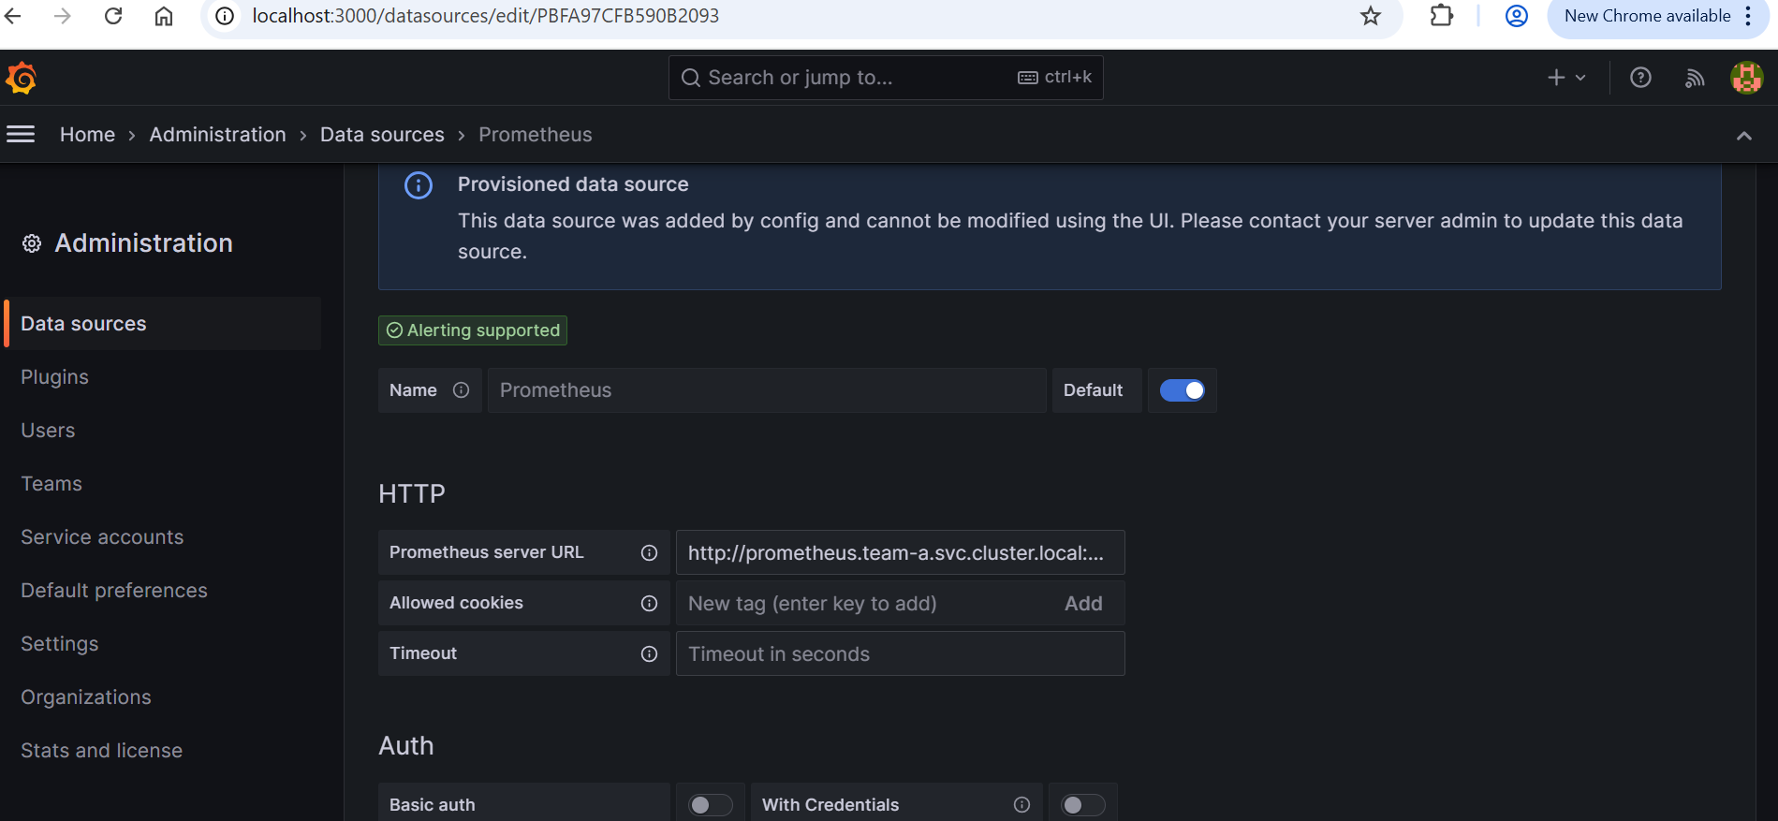

Teamb
kubectl port-forward -n team-b deploy/grafana 3001:3000

http://localhost:3001

